Requirement Analysis
Data Flow Diagram & User Stories
Date | 9 September 2026
Student Name | Laxmi Sai Priyanka
Project Name | Licensed Software Installation Request Management
Maximum Marks
Logical Data Flow
Step | Flow
1 | Employee opens the Service Portal and selects the Licensed Software Installation Request service.
2 | Employee opens the software installation catalog item.
3 | Catalog variables collect software name, requester details, priority, business justification, and required information.
4 | UI policies and validations display relevant fields and validate the request before submission.
5 | Employee submits the request and the system creates the request record and associated catalog task data.
6 | Workflow Studio starts the automated approval process based on the configured request conditions.
7 | Approval is routed to the appropriate approver; approval-required notifications are generated.
8 | After approval, a software installation task is assigned to the Software Support Team for fulfillment.
9 | The Software Support Team completes the installation task and the requester receives completion/status notification.

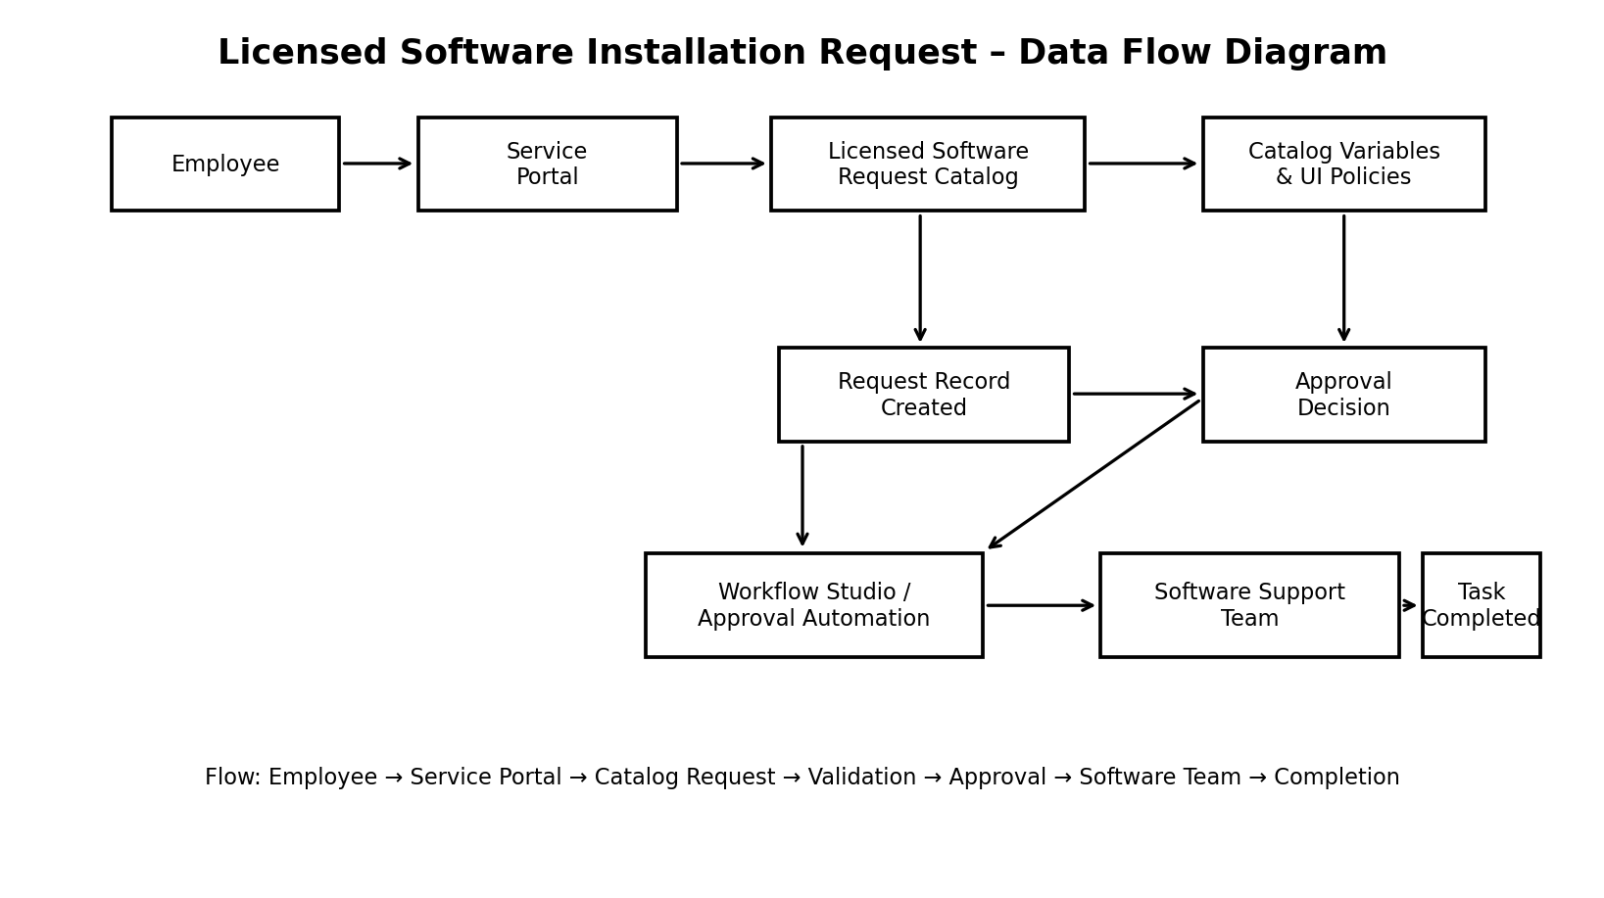
Flow: Employee → Service Portal → Catalog Request → Validation → Approval → Software Team → Request Completed
Figure 1: High-Level Licensed Software Installation Request Data Flow
User Stories
User Type | User Story | Acceptance Criteria | Priority
Employee | Find licensed software request service. | Service is visible in the Service Portal. | High
Employee | Enter software request details. | Required variables are available and validated. | High
Employee | Submit software installation request. | Request record is created successfully. | High
Approver | Review and approve/reject request. | Approval decision is recorded and workflow proceeds correctly. | High
Software Support Team | Receive and complete installation task. | Task is assigned and completion can be recorded. | High
Requester | Receive request/approval/completion notifications. | Relevant notifications are generated at configured stages. | High
Admin | Maintain catalog, workflow, notifications, and configuration. | Configuration is editable by authorized administrator. | Medium
Requirement Summary
The system is designed to provide a controlled ServiceNow process for requesting licensed software. The solution combines a Service Catalog item, configured variables and validations, approval automation, software-team fulfillment tasks, notifications, SLA/service configuration, testing, and deployment documentation.

